Standard Operating Procedure
Dozer Operation



ODISHA MINING CORPORATION LTD.
KODINGAMALI BAUXITE MINE

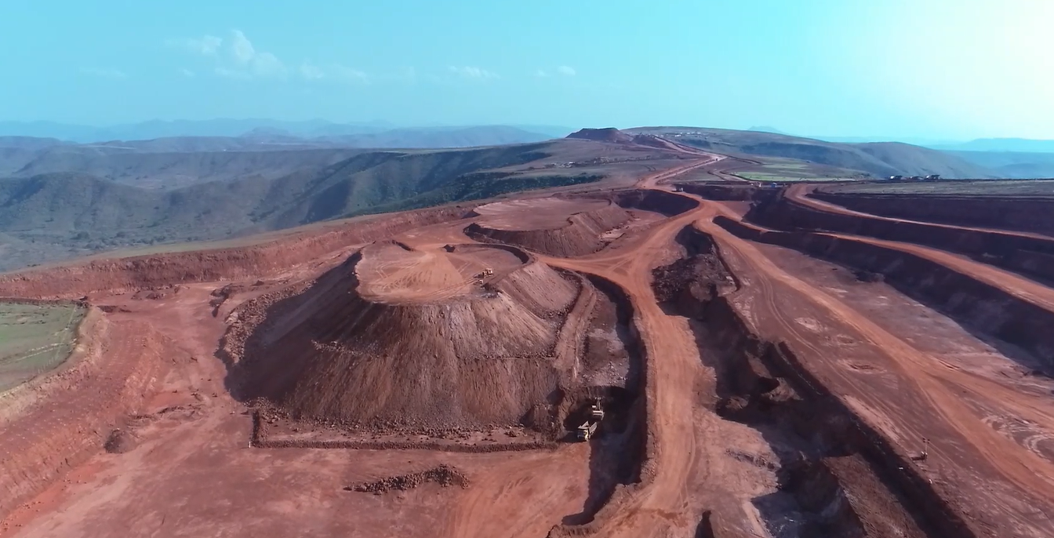

Authorized By
- PURPOSE:

To provide the Standard Operating Procedure for Dozer operation in Kodingamali Bauxite Mine.

- SCOPE:

This procedure is applicable for safe Operation of Dozer in Kodingamali Bauxite Mine.

- RESPONSIBILITY:

4.1 | Dozer Operation | Dozer Operator
4.2 | HEMM Maintenance | Maintenance vehicle Incharge
4.3 | Field Operation | Supervisor/Shift Incharge
4.4 | Operational Control | Area in-charge

- SAFETY AND HEALTH HAZARDS:

- Slip/trip/fall.
- Head on Collision.
- Roll Over/Toppling of water tanker.
- Hitting to other Truck/Structure/Persons.
- Dust generation during Operation.
- Noise during Operation.
- Vibration during Operation.
- Diesel/ Hydraulic Oil - Inflammable, Fire hazards.
- Acid Batteries- Skin contact can lead to extensive and severe burns and highly toxic.

In order to avoid injuries to personal and damage to machinery, the following precautions are very important.
- Work required PPE i.e. with safety shoes, helmet, dust musk, fluorescent jacket suitable for long distance visibility etc.
- Adherence to Traffic Rules guidelines framed by Mines Manager.
- Pre Operation Safety features checklist.
- Regular Checks & Maintenance.
- Use seat belt while driving.

Note: Report immediately to Supervisor, Shift Incharge and Safety officer for any incident/accident.

- ENVIRONMENT ASPECT:

- Dust generation
- Noise Pollution
- Vibration
- Oil Spillage

Preventive measures:

- Regular Water Sprinkling on Haul Roads for dust control.
- Use of Dust Mask/Earplug
Control of leakages

- TOOLS:

All Work required PPEs like Safety Helmet, Safety shoes, Nose mask, Ear Plug & Jacket.

- PROCEDURE:

1. Prestart checkup of the Dozer.
2. Bring the Dozer from parking area to looking point.
3. Check the working area free from any man/machinery deployed.
4. Placing of Dozer Safety at working area.
5. Parking of Dozer Safety at parking area at the end of shift.

Duties of Dozer Operator

1. Pre-Operational Visual Checks:

Oils Leakages, fire Extinguishers, battery, electrical system, head lights, ladder, oil & grease spillages, track conditions, mirrors, wind glass, blade, arm, arm cylinder & etc.

2. Operational Visual Checks:

Oil levels, hydraulic pressures, temperature, reverse horn, seat belt, seat condition, ac condition, steering, levers & HSD levels tec.

3. Normal Operation:

- Ensure clearance from mechanical engineer for operation.
- Ensure that the site condition is safe for Dozer operation.
- Understand and follow instruction and information given by Supervisor on system of work, work procedures and precautions.
- Report to supervisors about any unsafe condition observed in connection with operation of Dozer and safe clearance at loading point.
- Make proper use and report defects of any safety device and protective equipment’s.
- Avoid lilting of Dozer beyond safe limits..
- Stop operation and report to supervisor regarding any damage, malfunctioning or suspect defect of the M/C, abnormal noise, vibration, smoke, smell, temperature, movement.
- Ensure that Dozer is always parked on firm, level ground, with Blade rest on surface, and drive and controls disengaged, remove key and cabin locked.

4. Repair & Maintenance:

- Ensure maintenance schedule.
- Maintenance should be done in workshop under the supervision of mechanical engineers.
- If any Break downs taken place, inform immediately to this supervisors.
- Inform proximity hazards in the work place to the immediate superior official.

